Data type informations

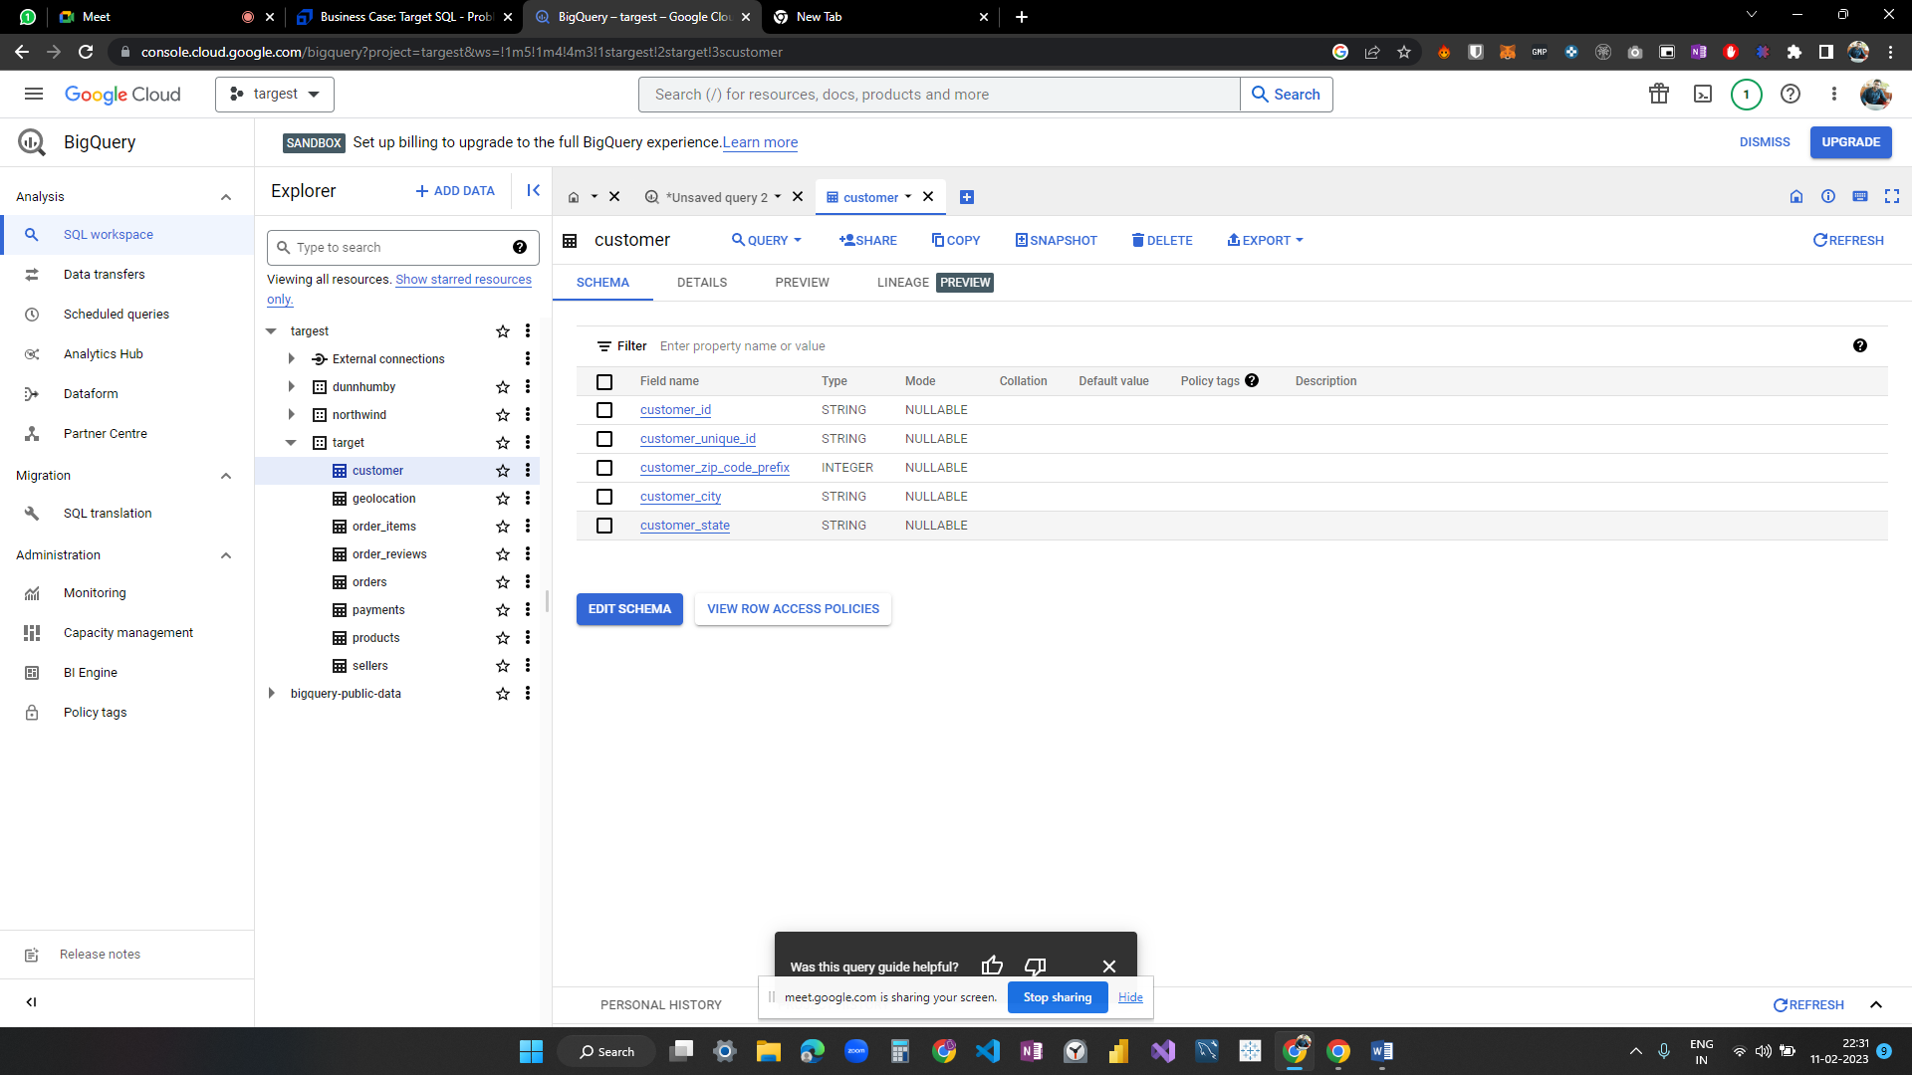

Time period for which the data is given

select min(order_purchase_timestamp) as min_date,

max(order_purchase_timestamp) as max_date

from `target.orders`

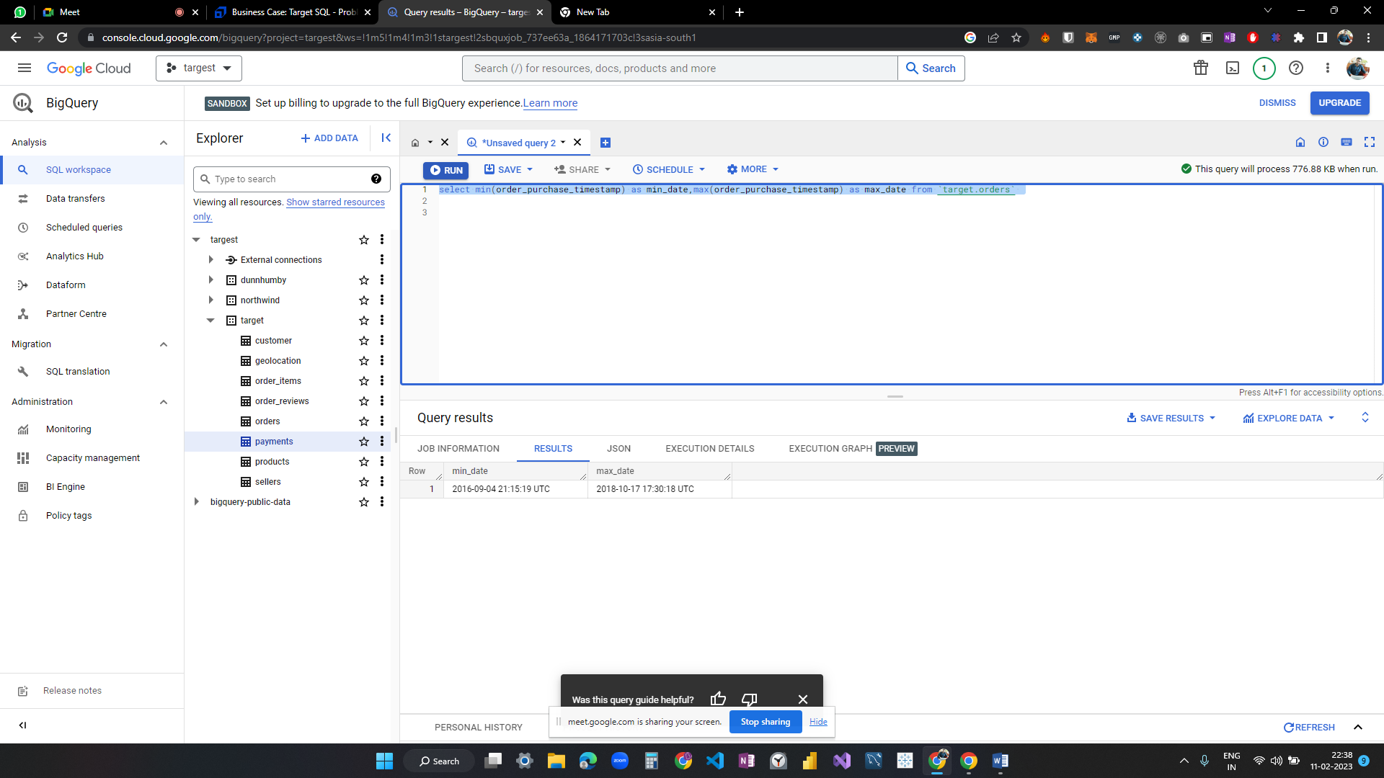

Cities and States of customers ordered during the given period

select distinct(geolocation_city) as city,

(geolocation_state) as state

from target.geolocation

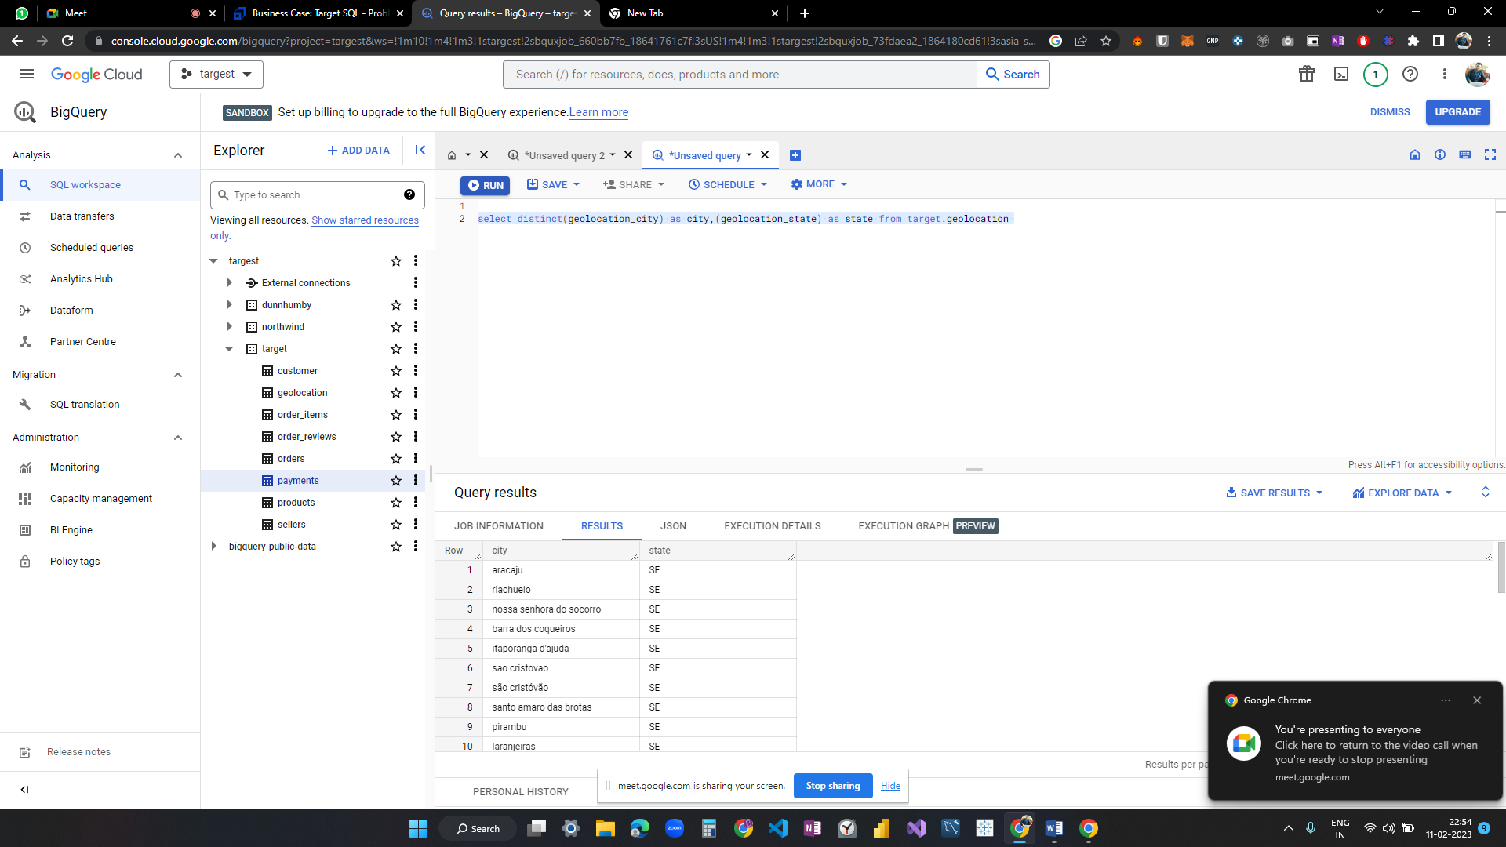

Is there a growing trend on e-commerce in Brazil? How can we describe a complete scenario? Can we see some seasonality with peaks at specific months?

select extract(month from order_purchase_timestamp) as month,

extract(year from order_purchase_timestamp) as year ,

count(order_id) as no_of_orders

from `target.orders` group by year, month

order by no_of_orders , year ,month

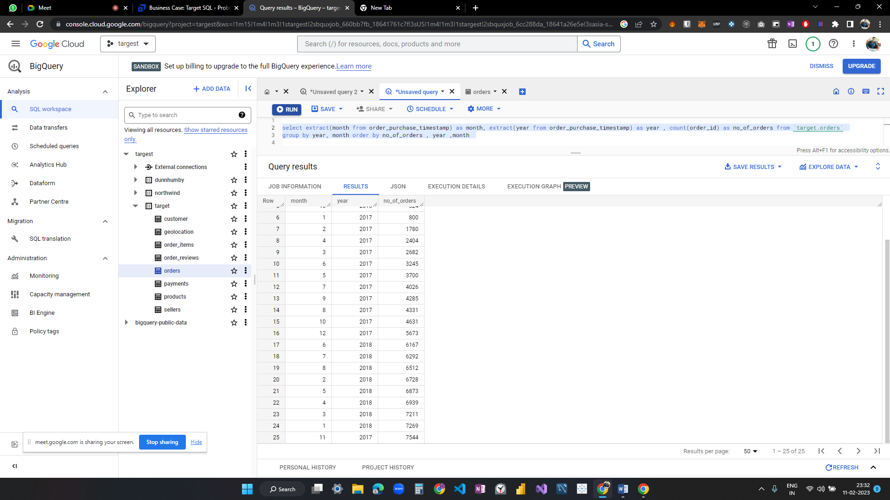

As we can observe no of orders are increasing almost on monthly basis with some slight dip oin no of orders but overall it is increasing

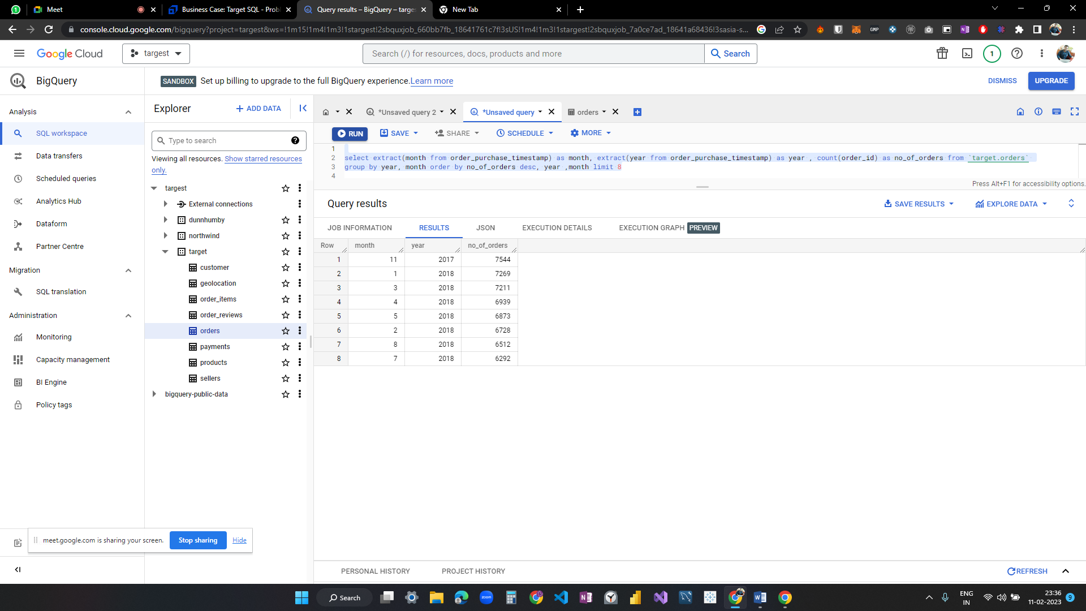

As we cannot observe any outlier in any month, we fail to accept that there is any peak sale due to season.

What time do Brazilian customers tend to buy (Dawn, Morning, Afternoon or Night)?

select case when extract(hour from order_purchase_timestamp) between 4 and 5 then "dawn"

when extract(hour from order_purchase_timestamp) between 5 and 12 then "morning"

when extract(hour from order_purchase_timestamp) between 12 and 18 then "afternoon"

else "night"

end as time_of_day,

count(order_id) as no_of_orders

from `target.orders`

group by time_of_day

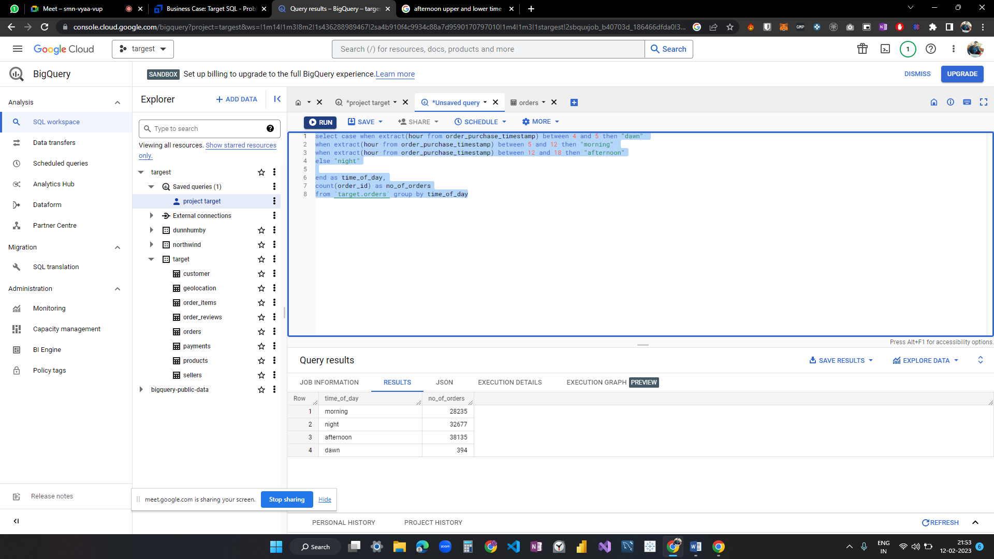

Most brazillian do shopping in afternoon i.e from 12 pm to 6 pm so if we want to run some offer that will be perfect time and we can consider this time as feasible for reaching out to customers

Get month on month orders by states

select  c.customer_state,

extract(month from o.order_purchase_timestamp)as month,

count(order_id) as no_of_orders

from `target.orders` o join `target.customer` c on o.customer_id = c.customer_id

group by c.customer_state,month

order by c.customer_state,month

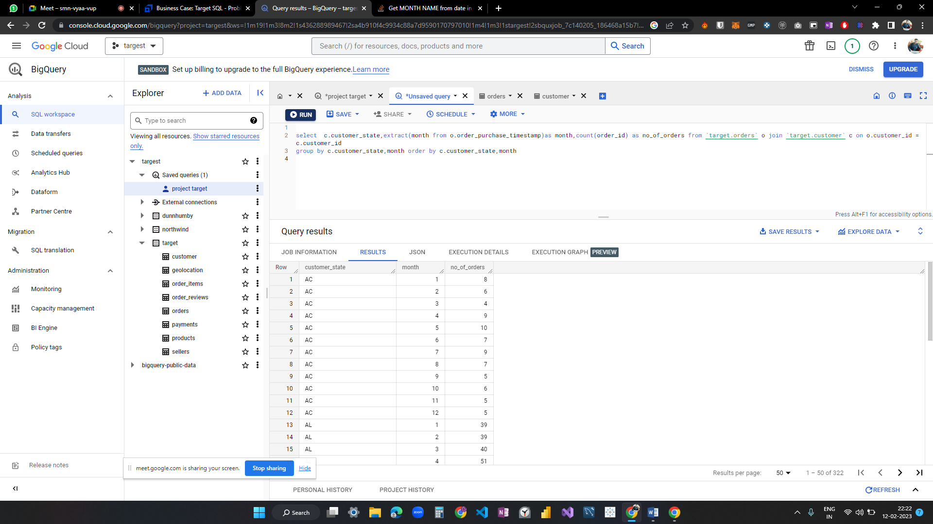

Trying month name

select  c.customer_state,

 format_date("%B",extract(date from o.order_purchase_timestamp)) as month,

count(order_id) as no_of_order from `target.orders` o

join `target.customer` c on o.customer_id = c.customer_id

group by c.customer_state,month

order by c.customer_state,month

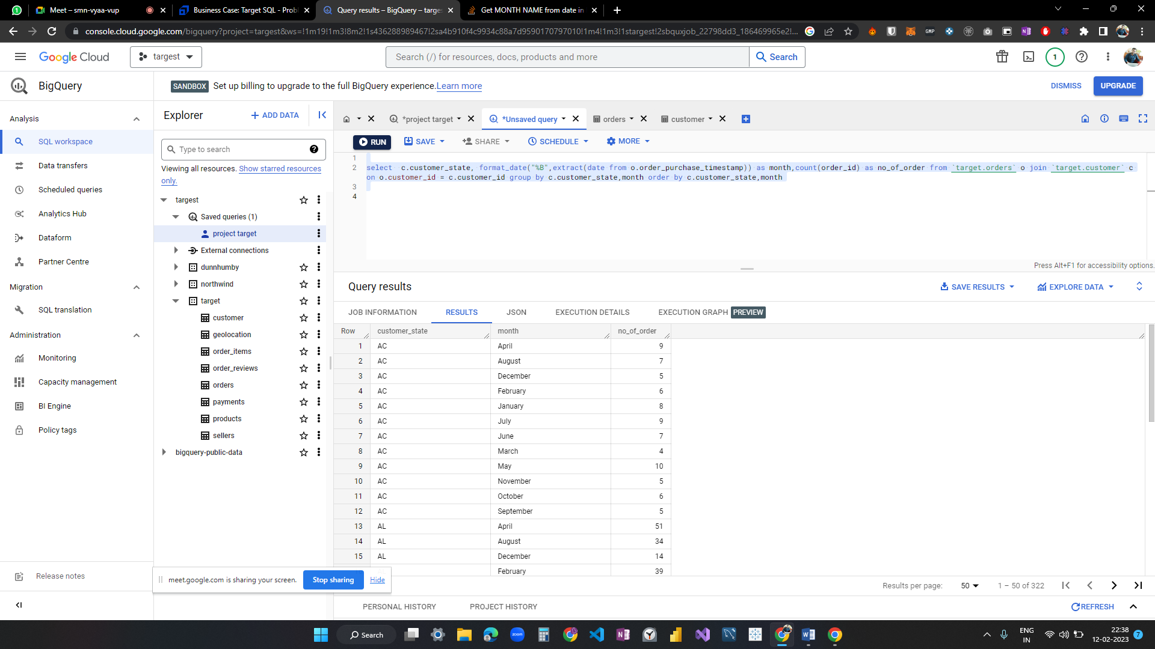

Distribution of customers across the states in Brazil

select customer_state,

count(customer_unique_id) as no_of_customer

from `target.customer`

group by customer_state

order by no_of_customer desc

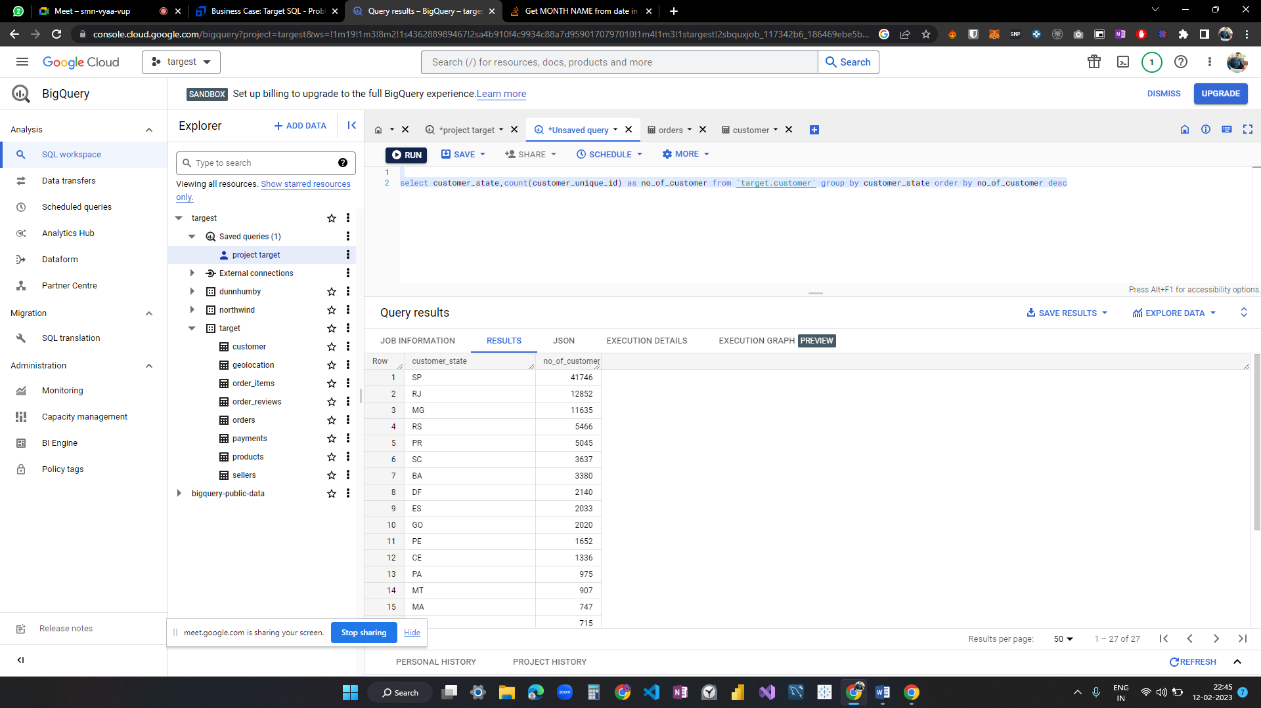

Get % increase in cost of orders from 2017 to 2018 (include months between Jan to Aug only) - You can use “payment_value” column in payments table

with base as(

select extract(year from

order_purchase_timestamp ) as year,

extract(month from order_purchase_timestamp ) as month,

p.payment_value total from `target.payments` p join `target.orders` o on p.order_id = o.order_id

)

, base2 as(

select base.year,sum(total) as total from base where (base.year between 2017 and 2018) and (base.month between 1 and 8) group by base.year)

,base3 as(

select base2.year as year,total,lead(base2.total) over (order by base2.year ) as next_year from base2)

 select year,( (next_year - base3.total )/total )*100 as percent_increase from base3

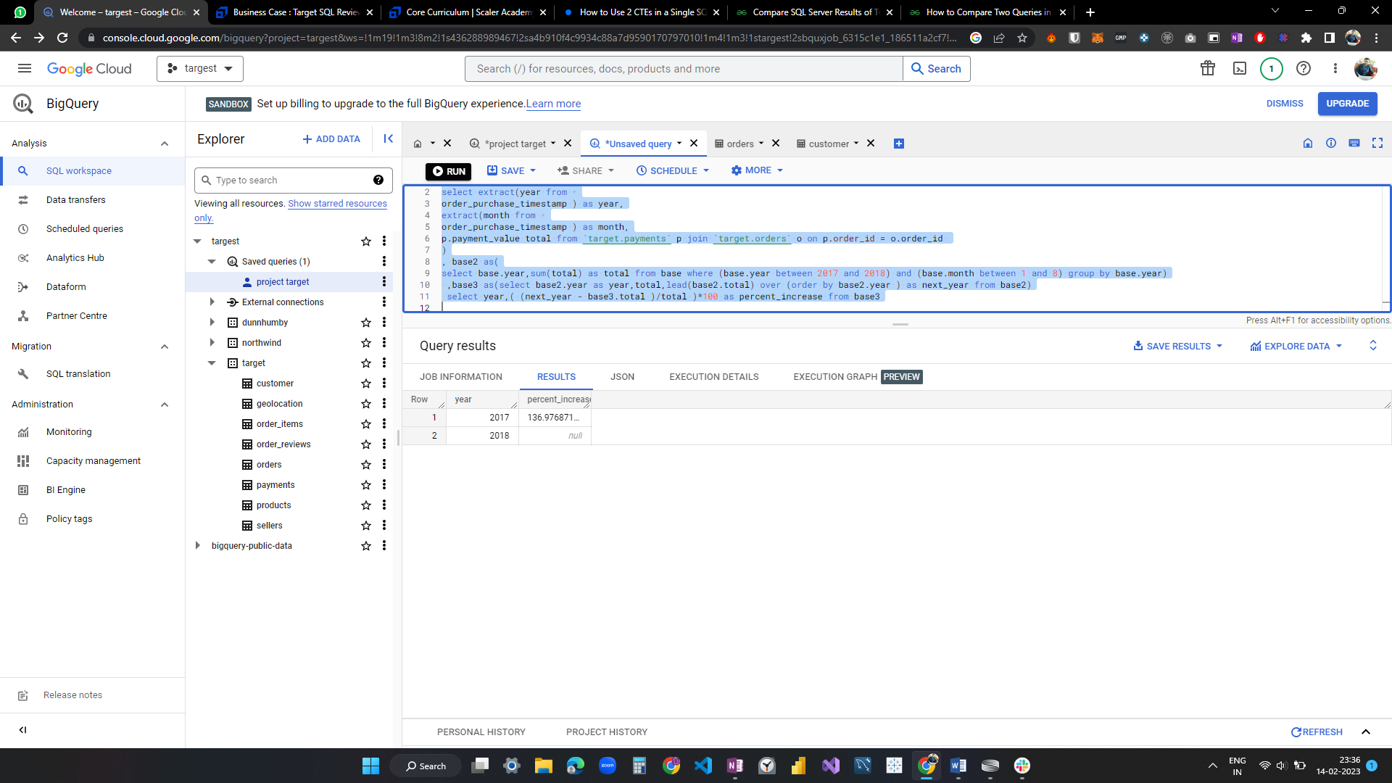

Mean & Sum of price and freight value by customer state

select customer_state,

avg(price) as avg_price,

avg(freight_value) as avg_freight_value,

sum(price) as sum_price,

avg(freight_value) as avg_frieght

from `target.orders` o join `target.order_items` as ot on o.order_id = ot.order_id

join target.customer c on o.customer_id = c.customer_id

group by customer_state

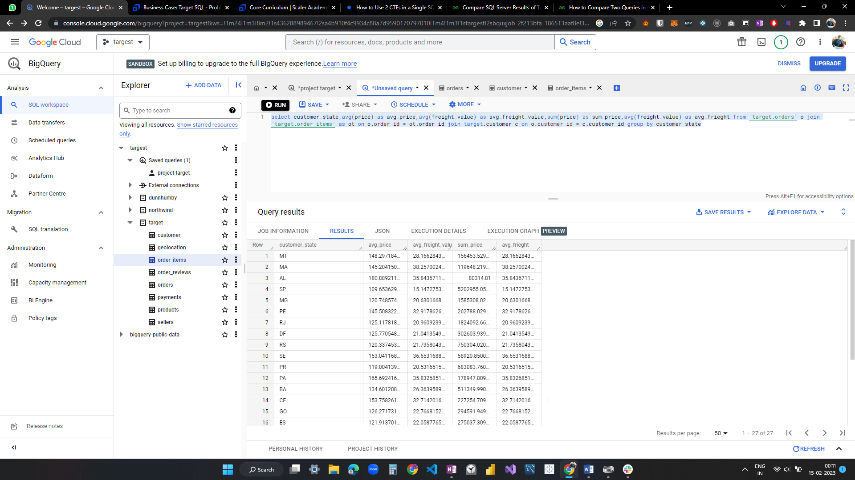

Calculate days between purchasing, delivering and estimated delivery

select order_id,

date_diff(order_estimated_delivery_date, order_purchase_timestamp, day)

as estimated_delivery_day,

date_diff(order_estimated_delivery_date, order_delivered_customer_date, day)

as delivered_day

from `target.orders`

order by delivered_day desc

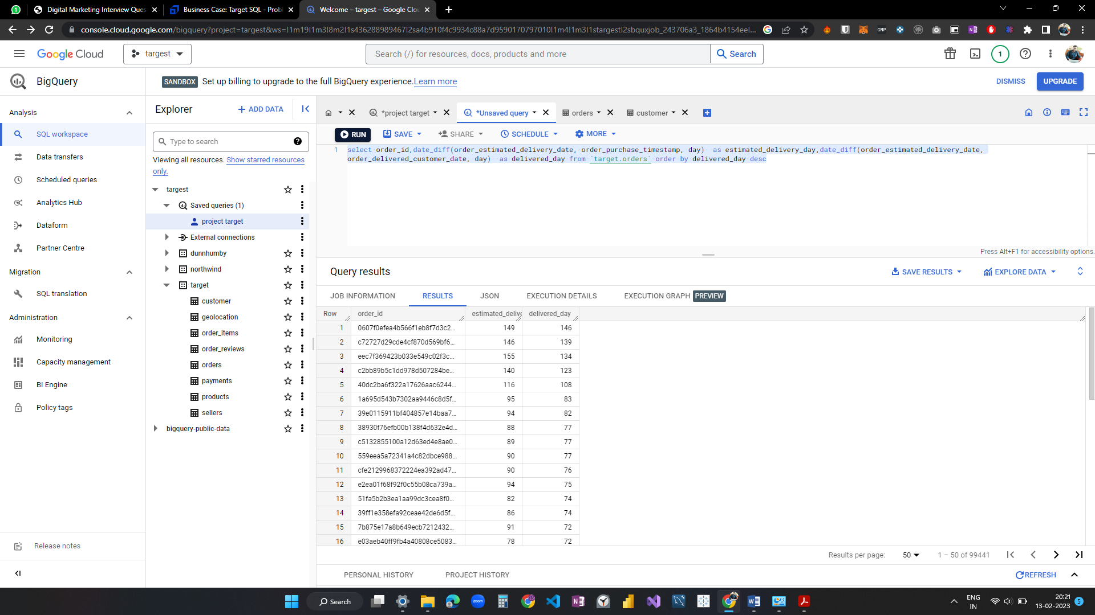

Find time_to_delivery & diff_estimated_delivery. Formula for the same given below:

* + time_to_delivery = order_purchase_timestamp-order_delivered_customer_date
  + diff_estimated_delivery = order_estimated_delivery_date-order_delivered_customer_date

select order_id,

date_diff(order_delivered_customer_date, order_purchase_timestamp, day)

 as time_to_delivery,

date_diff(order_estimated_delivery_date, order_delivered_customer_date, day)

as diff_estimated_delivery

from `target.orders`

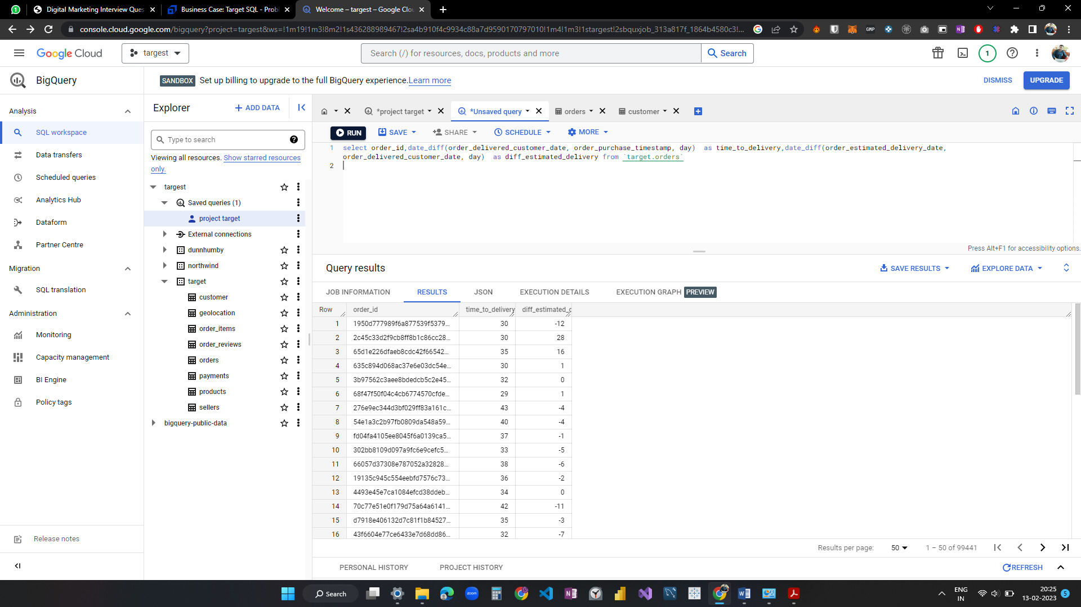

Group data by state, take mean of freight_value, time_to_delivery, diff_estimated_delivery

select c.customer_state,

avg(ot.freight_value) as freight_value,

avg(date_diff(order_delivered_customer_date, order_purchase_timestamp, day))

as time_to_delivery ,

avg(date_diff(order_estimated_delivery_date, order_delivered_customer_date, day))

as diff_estimated_delivery

from `target.orders` o join `target.order_items` ot on o.order_id = ot.order_id

join `target.customer` c on o.customer_id  = c.customer_id

group by c.customer_state

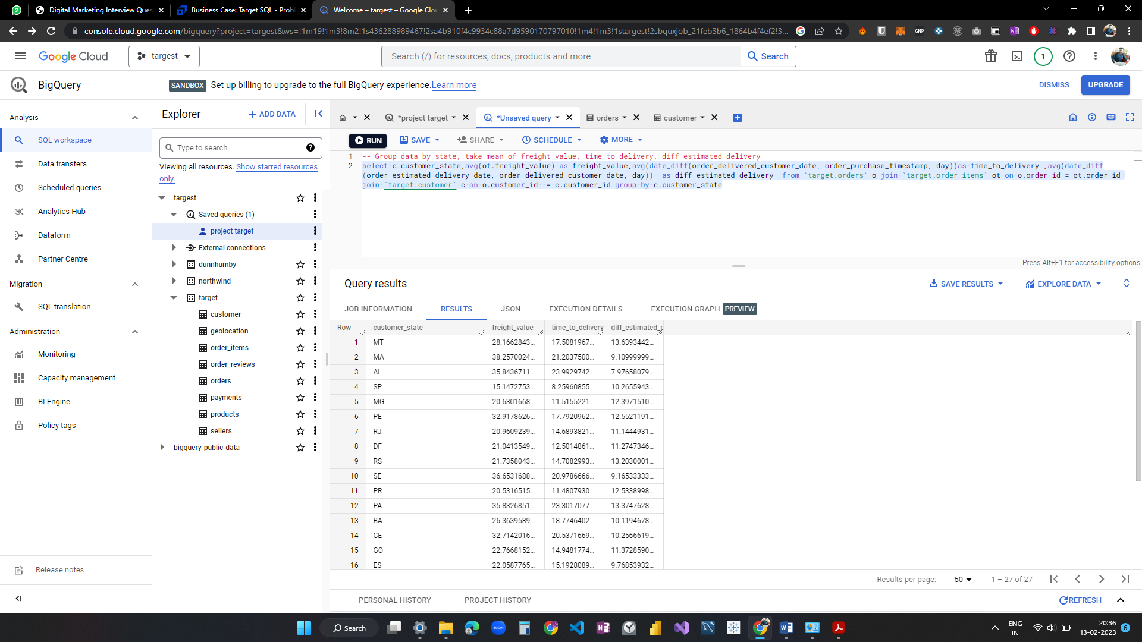

Top 5 states with highest/lowest average freight value - sort in desc/asc limit 5

select c.customer_state,

avg(ot.freight_value) as freight_value,

avg(date_diff(order_delivered_customer_date, order_purchase_timestamp, day))

as time_to_delivery ,

avg(date_diff(order_estimated_delivery_date, order_delivered_customer_date, day))

as diff_estimated_delivery

from `target.orders` o join `target.order_items` ot on o.order_id = ot.order_id

join `target.customer` c on o.customer_id  = c.customer_id

group by c.customer_state

order by freight_value desc

limit 5

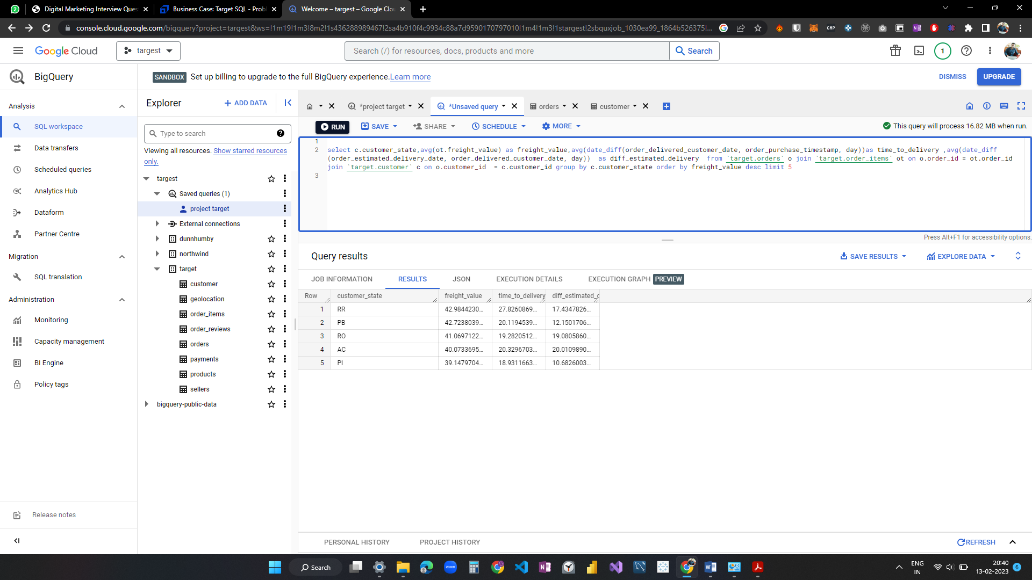

Top 5 states with highest/lowest average time to delivery

select c.customer_state,

avg(ot.freight_value) as freight_value,

avg(date_diff(order_delivered_customer_date, order_purchase_timestamp, day))

as time_to_delivery ,

avg(date_diff(order_estimated_delivery_date, order_delivered_customer_date, day))

as diff_estimated_delivery

from `target.orders` o join `target.order_items` ot on o.order_id = ot.order_id

join `target.customer` c on o.customer_id  = c.customer_id

group by c.customer_state

order by time_to_delivery desc

limit 5

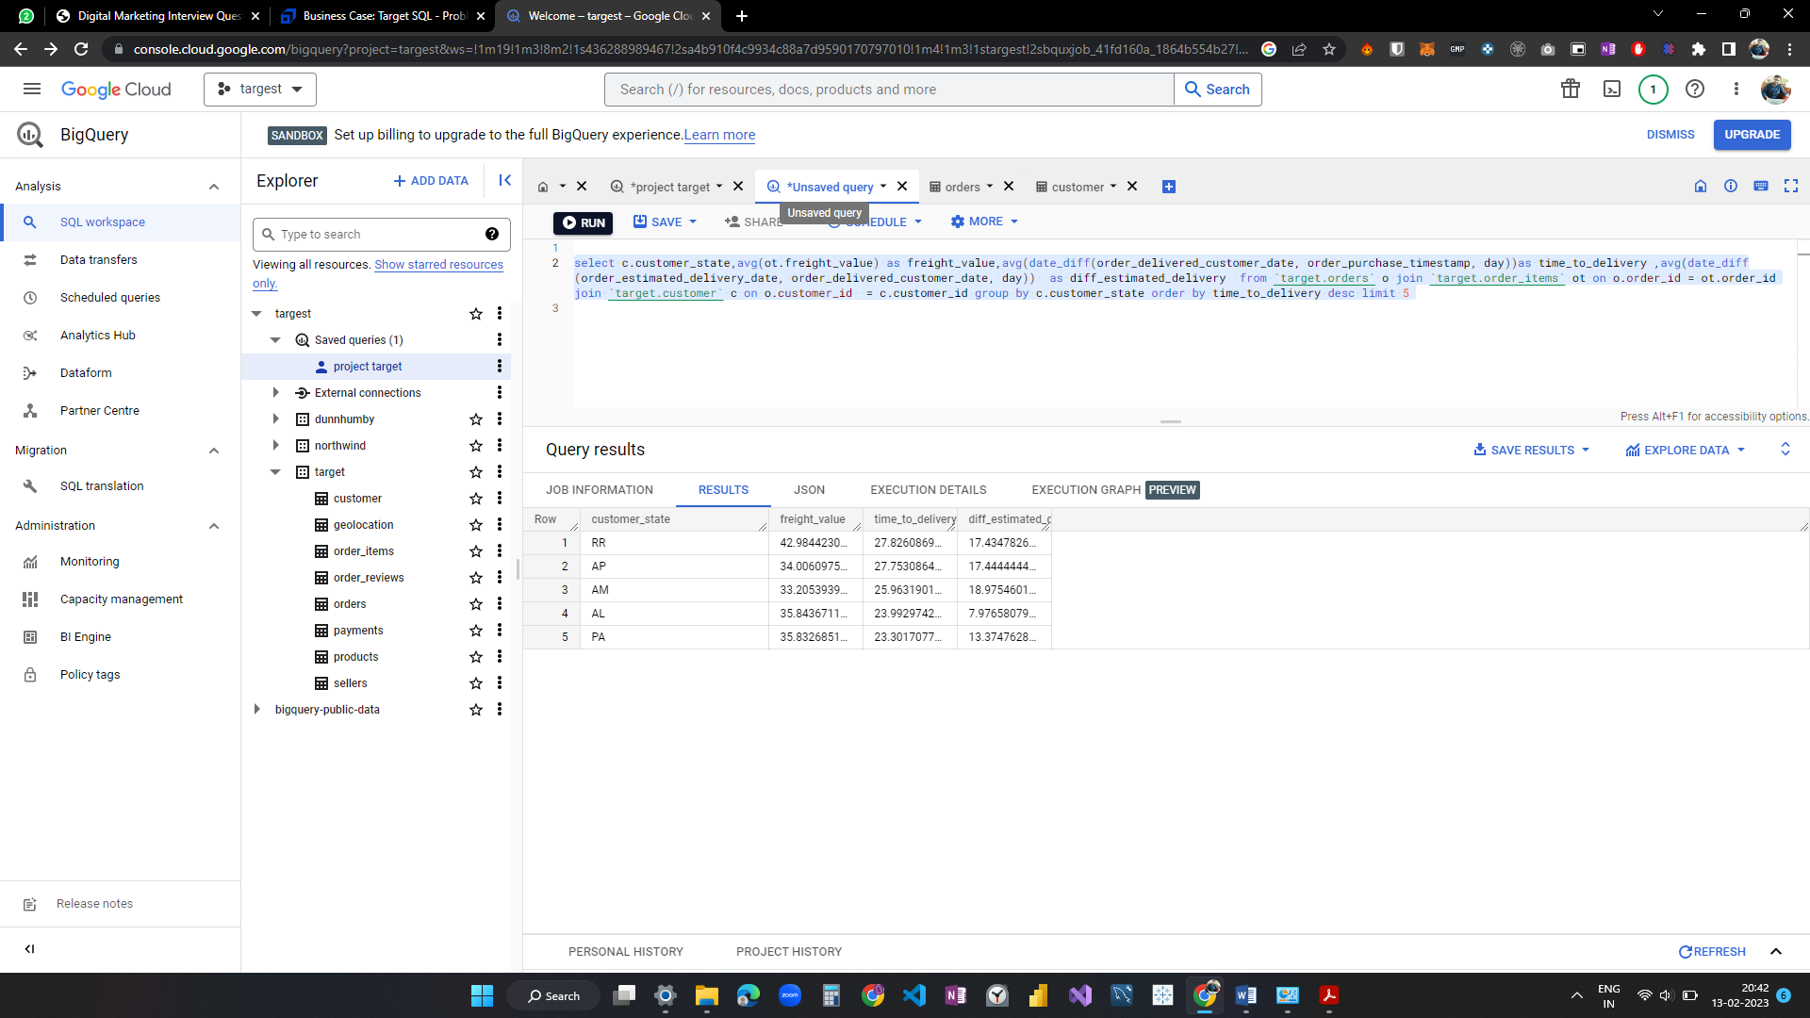

--Top 5 states where delivery is really fast/ not so fast compared to estimated date

select c.customer_state,

avg(ot.freight_value) as freight_value,

avg(date_diff(order_delivered_customer_date, order_purchase_timestamp, day))

as time_to_delivery ,

avg(date_diff(order_estimated_delivery_date, order_delivered_customer_date, day))

as diff_estimated_delivery

from `target.orders` o join `target.order_items` ot on o.order_id = ot.order_id

join `target.customer` c on o.customer_id  = c.customer_id

group by c.customer_state

order by diff_estimated_delivery desc

limit 5

Month over Month count of orders for different payment types

select extract(year from o.order_purchase_timestamp) as year,

format_date("%B",extract(date from o.order_purchase_timestamp)) as month_name,

extract(month from o.order_purchase_timestamp) as month_number,

p.payment_type,

count(o.order_id) as no_of_transactions from `target.orders` o

join target.payments p on o.order_id = p.order_id   
group by year, month_name,month_number,p.payment_type

order by year,month_number asc,p.payment_type

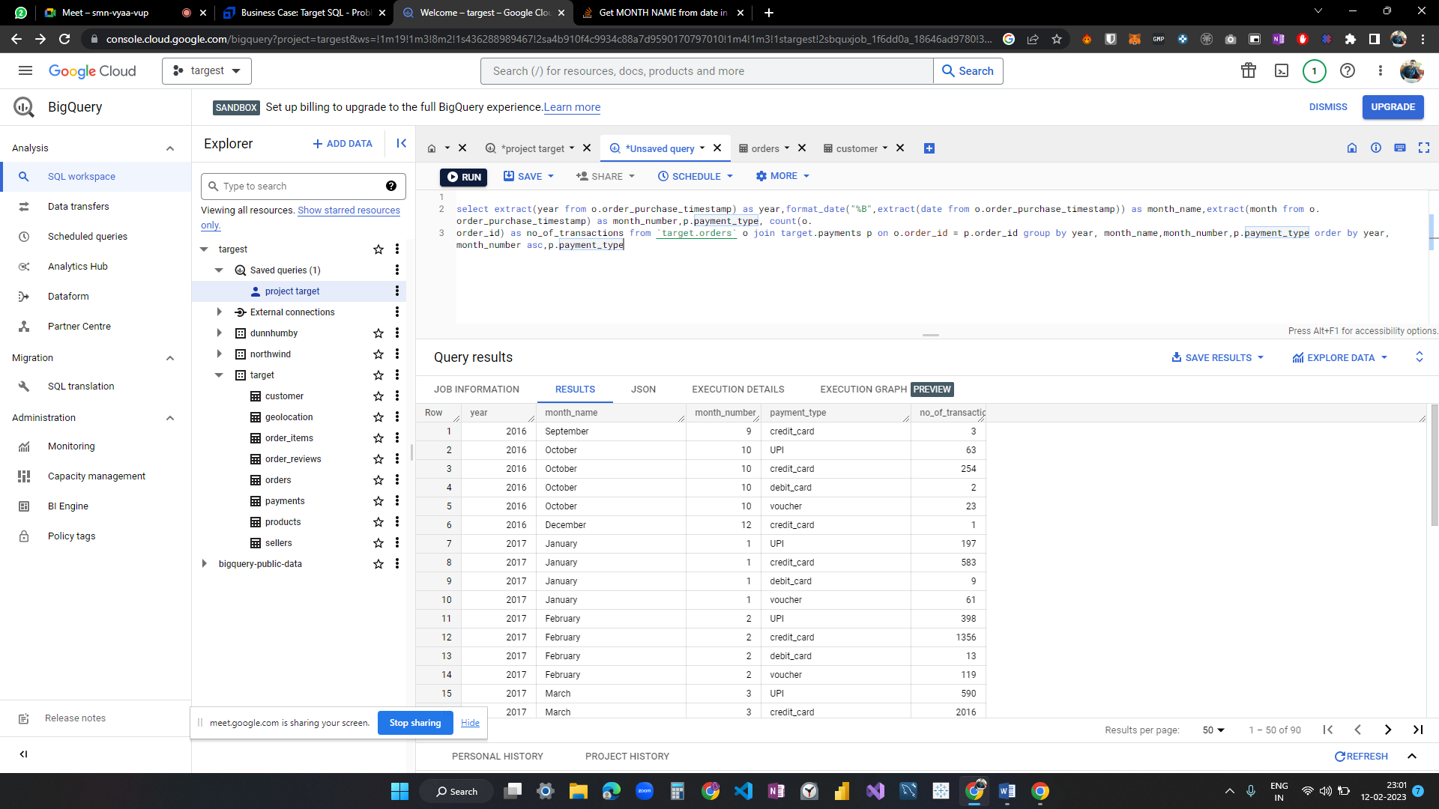

Count of orders based on the no. of payment installments

select payment_installments,

count(order_id) as no_of_payments

from `target.payments`

group by payment_installments

